**Update to Website: First Submission**

**(The Tag Line aka Mission Statement remains same despite changing length)**

**HOME PAGE** All **Pages https:// *(What bit encryption can we afford? Do we need to go through GoDaddy about this question? How about a virus, worm, etc. checker on our site to prevent contamination? Price?)***

**Kendrix’s Opinion**

**What bit encryption can we afford? It’s not about bit encryption, but Certificate Authority that signed and maintain a certificate. Who offers a cheaper price for what we need (we need a single domain certificate with base 256 encryption). STAYING W GODADDY at current fee with 256-bit encryption.**

**Here are top 4 CA’s:**

**1) Comodo: $99/yr**

[**https://www.comodoca.com/en-us/solutions/tls-ssl-certificates/**](https://www.comodoca.com/en-us/solutions/tls-ssl-certificates/)

**2) Symantec (aka Norton) - no longer supports. They gave this product/process to Digicert**

**3) Godaddy: $74/yr**

[**https://www.godaddy.com**](https://www.godaddy.com)

**4) Golobal Sign: $249/yr**

[**https://www.globalsign.com/en/ssl/domain-ssl/**](https://www.globalsign.com/en/ssl/domain-ssl/)

**4) Digicert (used by TBON): $198/yr or $188/2yr**

[**https://www.digicert.com/compare-and-buy-ssl-certificates/?s\_kwcid=AL!6100!3!4151064620!176716706!8476420946!147179908972!certificate%20authorities%20list!e!c!1t2&gclid=CjwKCAiAt4rfBRBKEiwAC678KWPrKMoYUvyQE3danNtJS8WbY0WTAJVq3x4unRfznWTnSwvIHJCS2xoCEyUQAvD\_BwE**](https://www.digicert.com/compare-and-buy-ssl-certificates/?s_kwcid=AL!6100!3!4151064620!176716706!8476420946!147179908972!certificate%20authorities%20list!e!c!1t2&gclid=CjwKCAiAt4rfBRBKEiwAC678KWPrKMoYUvyQE3danNtJS8WbY0WTAJVq3x4unRfznWTnSwvIHJCS2xoCEyUQAvD_BwE)

**Wikipedia shows Godaddy as a top 3 CA.**

[**https://en.wikipedia.org/wiki/Certificate\_authority**](https://en.wikipedia.org/wiki/Certificate_authority)

**5). Free option: a Self-Sign certificate I can produce for you, but no guarantees. Hacking issues are all JMA responsibility, no protection from a CA, because it’s self-signed.**

[**https://letsencrypt.org/**](https://letsencrypt.org/)

**Do we need to go through GoDaddy about this question? No – this is something I am very very familiar. The above I hope answers your question, if not please let me know.**

**How about a virus, worm, etc. checker on our site to prevent contamination?**

**Sites are affected only if they are not secure (ssl). Documents are affected the endpoint (at the source/destination). A Secure site prevents all the above during the transfer. I personally uses Norton to inspect my documents when I’m downloading from the web. Again a document is already effected before the transfer.**

**Price? See 1-4, $value**

**HEADER**: NEW LOGO on LEFT with Static Non-copy Righted montage of nurses working in various disciplines: operating room, dialysis, geriatrics, pediatrics, pediatrics, neonatal intensive care, etc.

**BUTTONS** below HEADER entitled (Please distinctively & professionally shape the BUTTONS ☺)

|  |  |  |  |  |  |
| --- | --- | --- | --- | --- | --- |
| Home | About Us | Class Descriptions | Calendars | Contact Us | Internet Resources |

Below BUTTONS changing pictures entitled (See bon.texas.gov for examples, please.):

1. ***Nursing Remediation***
   * **Classes** with active link to the **Course Description Page**
   * **Class Dates** with active link to the **Calendar**
2. ***Services***
   * Verification of Completion with active link to the Verification Data
     1. Texas Board of Nursing Orders
     2. Peer Review Committee Orders
     3. Attorney Recommendations
3. ***Mission Statement*** *–* with an active link to this statement: The Mission of JMA Nursing Consultant (JMANC) is to*present and promote learning - knowledge and strategies - within an atmosphere that fosters professional growth and competency in legal and ethical Texas nursing practice for all clients*.
4. ***History*** – with an active link to this information: JMANC presentations to small classes began in June 2002 for Texas and endorsing nurses who were complying with Texas Board of Nursing or Peer Review Committee stipulations.
5. ***Bottom of Page Data***

* P. O. Box 24083, Fort Worth, TX 76124-1083‖P: (817) 845-1937‖(Can you, please make clicking on the number dial it?) ‖F: (817) 451-3557 ‖Email: [jmanc101@sbcglobal.net](mailto:jmanc101@sbcglobal.net) (Please, fix the link to open the email on the visitor’s phone—android and iOS/computer—windows and iOS.)

**Kendrix Opinion**

I think but not sure tel: attribute understands the device and will bring up the app associated with dialing the phone number.

I also believe mailto: attribute understands to pull up the associated email default on that device (ex windows MS Outlook, android Email Client).

* **Promote professional growth and competency. (Following the color oomph color scheme you chose.)**

**ABOUT US PAGE**

* Same as the *Mission Statement* link
* Standards of Practice

1. JMANC is dedicated to delivering excellent service to our clients and perspective clients via the telephone, text message, email, and or the United States Postal Service. Each participant packet is comprehensive and clearly communicates class content. We respond to requests for information in a timely manner. We seek feedback and timely respond to client and website visitor feedback. JMANCs founder and instructor, Jeanette Anderson, MSN, RN, is a nurse with experience in critical care, medical-surgical nursing and nurse education; and rose through the ranks of licensed vocational, associate degree, and baccalaureate degree nursing to arrive at a Master of Science in Nursing in adult care and education. Her professional experience includes:
   * Owner of ***JMANC***  since April 2002 present
   * Consulted with the Texas Board of Nursing, August December 2007
   * Adjunct Associate Professor of Nursing at Tarrant County College District from January 1984 thru December 2001
   * Vice President/Co-Owner of M&M Nurse Review Centre June 1993 May 200
   * Clinical experience covers working as a LVN on medical-surgical units and as a RN working in medical-surgical, intensive care, telemetry, cardiac care, and oncology units spanning August 1970 to December 2001.
   * Publications and Associations available upon request.

* Please send questions, comments, and or concerns to: [jmanc101@sbcglobal.net](mailto:jmanc101@sbcglobal.net) (Please, fix the link to open the email on the visitor’s phone—android and iOS/computer—windows and iOS.)
* **Kendrix Opinion**
* I also believe mailto: attribute understands to pull up the associated email default on that device (ex windows MS Outlook, android Email Client).

**CLASS DESCRIPTION PAGE**

1. Texas Nursing Jurisprudence = **Overview of Texas Nursing – Legal and Ethical Foundation** (***OTNLEF***) is:
   1. Structured for the nurse, registered and vocational, to learn, renew and or enhance knowledge, skills and strategies for delivery of safe, legal and ethical nursing care. The class teaches organized plans to meet and exceed Standards of Care through assessment and management of clinical settings. Upon completion of this workshop, the participant should have gained the tools and self-confidence to reduce legal and ethical clinical crises.
   2. Content includes: Nursing Practice Act, standards of practice, documentation of care, principles of nursing ethics, confidentiality, professional boundaries, and the Board’s Disciplinary Sanction Policies regarding: Sexual Misconduct; Fraud, Theft and Deception; Nurses with Substance Abuse, Misuse, Substance Dependency, or other Substance Use Disorder, and Lying and Falsification.
   3. **Link to REGISTRATION PAGE that allows client to enroll for classes separately or two at a time, sending the pay link upon submission of the registration form in the amount of $330.00 for each class or $650.00 when the client registers for two classes at one time, Please.**

**[Kendrix: See my comments on the last page for updating the Registration Page process]**

1. Nursing Documentation = **Documenting and Reporting Like Lives Depend On It – An Update** (***D&R***) is
   1. Designed for the registered and licensed vocational nurses who want to renew or enhance their knowledge, skills and strategies for safe, legal nursing documentation and reporting. The review teaches strategies to meet and exceed Standards of Care by developing procedures to prevent common documentation and reporting errors. Upon the completion, the participant should have gained the tools and self-confidence to reduce documenting and reporting errors.
   2. Content includes: nursing standards related to accurate and complete documentation; legal guidelines for recording; methods and processes of recording; methods of alternative record-keeping; and computerized documentation.
   3. **Link to REGISTRATION PAGE that allows client to enroll for classes separately or two at a time, sending the pay link upon submission of the registration form in the amount of $330.00 for each class or $650.00 when the client registers for two classes at one time, Please.**

**[Kendrix: See my comments on the last page for updating the Registration Page process]**

1. Class Fees: **You have done this previously and we will stick with your strategy.**
   1. One Class—The fee per class $330.00 (methods available: bank-to-bank, credit card, ATM card and PayPal.)
   2. Two Classes Price is $650.00—one payment and $330 each when paid separately (methods available: bank-to-bank, credit card, ATM card and PayPal)

**Kendrix Opinion**

**We want to push online registration over onsite, therefore online should be before onsite registration**

**Online Registration**: Online registration takes place with signing the Class Provision Guidelines, submitting online Registration Form, and make payment/s.

* Please download the [Class Provision Guidelines](https://www.jmanursingconsultant.com/Class_Provision_Guidelines.pdf), read it, sign, make a copy for your records using 1 of 2 options:  
    
  1. Sign Online and Email (**JMA prefer**). See how to video: [Sign Online and Email](https://www.jmanursingconsultant.com/onlinesign/JMADocuSign.htm)  
  2. Sign, scan, then email to JMANC at [jmanc101@sbcglobal.net](mailto:jmanc101@sbcglobal.net)

If you cannot complete the above options, please mail your signed copy to (JMA Nursing Consultant, P.O. Box 24083, Fort Worth, 76124-1083), or bring signed copy to class.

* Continue registering online, click on **Calendars**, identify your class or classes, submit the Registration Form, and make payment. The class link will take you through the proper steps.

**If you are registering from your employer’s network, they may block the registration process because it is secure. If blocked, please try on a Public Network (outside employer’s network).**

***Onsite Registration:*** For space available onsite registration, please call for availability. The Onsite fee is $350.00. Early registration strongly recommended as class size is limited to five (5). Please arrive with the completed **Class Provision Guidelines** (If not mailed.) and your **government issued photo id** for registration and continental breakfast beginning promptly at 0745 hours.

JMANC does NOT award CE for remedial classes. The Board does excludes remediation classes from inclusion to the two-year 20 CE requirements for license renewal. At the completion of the class, JMANC sends Verification of Completion (VOC) to the Board prior to your departure, provides you with an original signed VOC for your personal records, and retains a signed VOC in your file for five years. JMANC’s submission of the VOC to the BON requires a COMPLETE client file (registration form, a government issued photo id, the class evaluation, and your posttest).

**CALENDAR PAGE** – PLEASE, talk with Kendrick about the page setup. I want the color scheme for all the pages to be the same. Please, feel free to use different PowerPoint styles/formats to achieve dynamic presentation and flow.

**Kendrix’s Updates to Calendar:**

**SCHEDULE:**  Registration begins at 0745 Hours. Class Hours are: 0800 Hours - 1430 Hours.  
  
**CLASS DATES:** To register, scroll to the months/days and click on your chosen date. The Registration Form will appear.   
  
Please, do NOT complete Registration Form until ready to submit payment.

**JMA Nursing Consultant Class Schedules**

[ Google Calendar ]

**RESOURCES PAGE:**

1. Application and URL Information: **JMANC does not own interest nor receive compensation for the listings.**

* Apple App or Google Play for Waze App
* <google_maps>
* <http://www.mapquest.com/directions/main.adp>
* <http://maps.yahoo.com/>

1. Lodging Information

* [Comfort Suites](http://www.comfortsuites.com/hotel-arlington-texas-TXB38), 411 Road to Six Flags , Arlington, TX, US, 76011, Phone: (817) 460-8700, Fax: (817) 460-8701
* [Courtyard Marriott Arlington by the Ballpark](http://rds.yahoo.com/_ylt=A0geupW6yn1EWTMBxhZXNyoA;_ylu=X3oDMTBxaW83N280BGNvbG8DZQRzZWMDc2MEdnRpZANGNjY2Xzc4/SIG=174cl8njl/EXP=1149180986/**http%3a/local.yahoo.com/details%3ffr=dd-local-tl1%26id=18838057%26stx=courtyard%2bmarriott%2barlington%26csz=Arlington%2bTX%26ed=Sr8VvK160SzUShMT.8ae7imMAw3k9bW_yqVHcAgYUk38SM4O31Q9020q28GeMNuNZi56e.P42Q6wySo-) - (817) 277-2774 or (800) 321-2211, 1500 Nolan Ryan Expressway, Arlington , TX 7601
* [Holiday Inn Arlington NE-Globe Life Park (Ranger Ball Park)](http://www.ihg.com/holidayinn/hotels/us/en/arlington/arlel/hoteldetail) 1311 Wet N Wild Way, Arlington, TX 76011; Reservations: (877) 834-3613
* [Holiday Inn Express & Suites](http://www.hiexpress.com/hotels/us/en/arlington/arlsf/hoteldetail) (817) 640-5454, 2451 E. Randol Mill Road, Arlington, TX 76011
* [La Quinta Fort Worth Eastchase](http://www.lqfortworth.com/?utm_source=google&utm_medium=plus&utm_campaign=Google+Plus) 8250 Anderson Blvd, Fort Worth, TX 76120; Reservations: (682) 237-7519 Fax (888) 709-5989  **\* Closes to class location.\***

## Registration Update

**Updating the Registration Page Process**

**Ms. Jeanette’s statement:**

**Link to REGISTRATION PAGE that allows client to enroll for classes separately or two at a time, sending the pay link upon submission of the registration form in the amount of $330.00 for each class or $650.00 when the client registers for two classes at one time, Please.**

**KENDRIX Opinion**

**This process will have to take place on the backend. I don’t want to complicate it, but what’s simple for the client? We are going with your diagram as revised**

**I think immediately providing the Invoice Page (Paypal) all in the same process, as described by Ms. Jeanette.**

**We need to research and generate the invoice links (Paypal).**

**When the client pay we automatically flip them to Active.**

**We need to make a decision to request payment before/after Class Guidelines is signed and uploaded?**

**See the email I sent Subject:** Sign Course Provision Document online

**DocuSign is the cheapest and I love it more.**

**Automation Alternative**

The most difficult is doing all this ourselves, but we will be liable of storing the signed document in

Google and can never never ever loose it.

This may take me 2-3wks.

a. Electronically sign a document (user basically clicks a button), we will create a unique hash key

and attach it to the pdf.

b. Load document on JMA Google space.

c. Send customer a link. The customer will have to create an encrypted password to

see/download the document

Next Page documents payment process options

**We decided with Automation B** (C may come in 2019)

Here’s the flow diagram

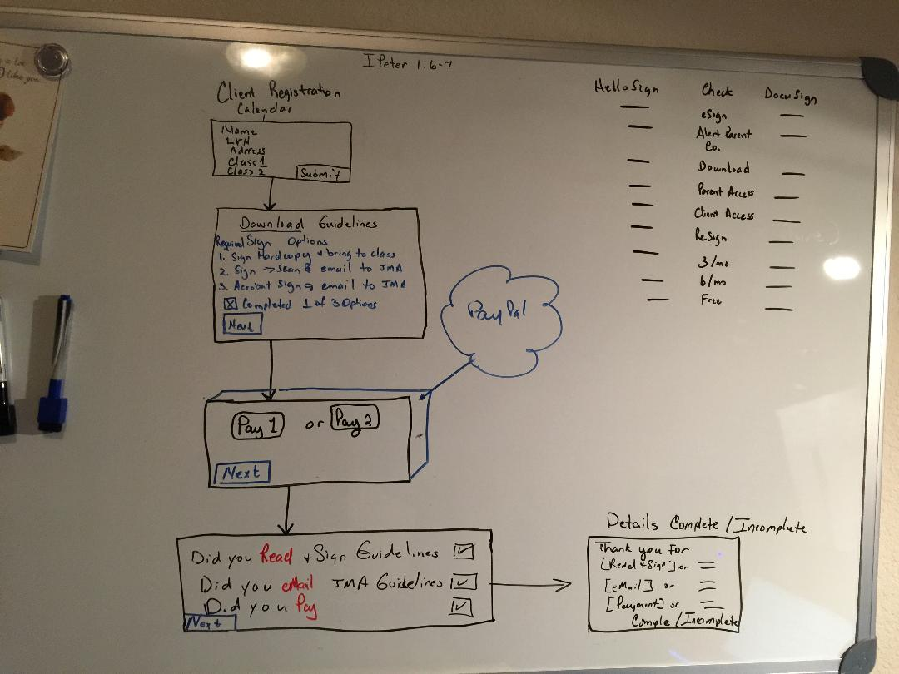

### **Payment process workflow options**

Manual A.

1. Client select class/es and submits the request.
2. Ms. Jeanette sends Invoice
3. Upon receiving payment, Ms. Jeanette switches client to “Active:Y”
4. Client can bring signed Class Guidelines copy with them to class.
   1. Refusal to sign Ms. Jeanette reimburse based on time/resources spent.
5. Class starts

Manual B.

1. Client select class/es and submits the request and sees Invoice for class or classes.
   1. Client also gets email saying to send payment.
2. When Ms. Jeanette receives payment, Ms. Jeanette switches client to “Active: Y”
3. Client can bring signed Class Guidelines copy with them to class.
   1. Refusal to sign Ms. Jeanette reimburse client based on time/resources spent.
4. Class starts

Automation A – Class Guidelines: customer print, sign, scan, and send back.

1. Client select class/es and submit the request and sees Invoice for class or classes.
   1. Client gets email as saying to send payment.
2. Ms. Jeanette sends Class Guideline for online signature. Client will print, sign, scan, and email back to Ms. Jeanette.
   1. Client can bring signed Class Guidelines copy with them to class.
3. When Ms. Jeanette receives payment and **signed** Class Guidelines, then manually switches client to “Active: Y”
   1. Save Guideline as hardcopy, in email, and our system.
      1. Create a special folder in email with signed Class Guidelines auditing.
4. Class starts

Automation B – Class Guidelines: customer uses Adobe Reader to sign document.

1. Client select class/es and submit the request and sees Invoice for class or classes.
   1. Client gets email as saying to send payment.
2. Ms. Jeanette sends Class Guideline for online signature with link ([how to sign using Adobe](http://www.jmanursingconsultant.com/onlinesign/JMADocuSign.htm)). Client uses Adobe Acrobat Reader DC to online sign and email back to Ms. Jeanette.
3. When Ms. Jeanette receives payment and **signed** Class Guidelines, uploads the Class Guidelines, the system switches client to “Active: Y”
   1. Save Guideline as hardcopy, in email, and our system.
      1. Create a special folder in email with signed Class Guidelines auditing.
4. Class starts

Automation C – DocuSign.com, HelloSign.com (provides link for client to sign Class Guidelines).

1. Client select class/es and submits, client must check read[x] Course Guideline, check received and signed[x] Guideline, then client sees Invoice for class or classes.
   1. Client gets email to **sign** Class Guidelines
   2. Client gets email as saying to send payment, only necessary if it was not done above.
2. When Ms. Jeanette receives email payment made and Class Guidelines uploads the Class Guidelines, the system switches client to “Active: Y”
   1. Save Guideline as hardcopy, in email, and our system.
      1. Create a special folder in email with signed Class Guidelines auditing.
3. Class starts

Automation C. Allow those with time and experts secure and maintain document.

Automation D – System electronically signs Class Guideline. $30/hr (Research & Develop) – I will log my time.

1. Client select class/es and submits, client must select read[x] Course Guideline, next client ask to electronically sign[x] Guideline, client gets email of signed Guideline to bring to class, client confirms receiving email[x], then client sees Invoice for class or classes.
   1. Client gets email as saying to send payment.
2. When Ms. Jeanette receives email payment made and switches client to “Active: Y”
3. Class starts

Automation D. Requires securing data online and monitoring space. I DO NOT LIKE THIS OPTION.